

Ms Swathi
Cherukumalli Vivek
2520030532
CSE
CO-1
Case study Topic: CivicEye – Smart City Incident Monitoring & Response System (CO1)

In this case study, we implemented Binary Search Tree (BST) and AVL Tree structures for the CivicEye Smart City Incident Monitoring & Response System.
The BST was used to index incidents using IncidentID for quick searching and retrieval.
The AVL Tree maintained balanced complaint databases to ensure efficient insertion, deletion, and searching operations.
Tree traversal techniques were applied to generate sorted incident reports.

Implementation Details:
- Implemented Binary Search Tree (BST) to store and search incidents using IncidentID.
- Used AVL Tree for balancing city complaint databases.
- Applied tree traversals (Inorder, Preorder, Postorder) to generate sorted incident reports.
- Performed AVL rotations (LL, RR, LR, RL) whenever imbalance occurred.
- Compared BST and AVL performance for incident record management.
- Concluded AVL Tree improves efficiency for large-scale smart city monitoring systems.

Result: Screenshots / output

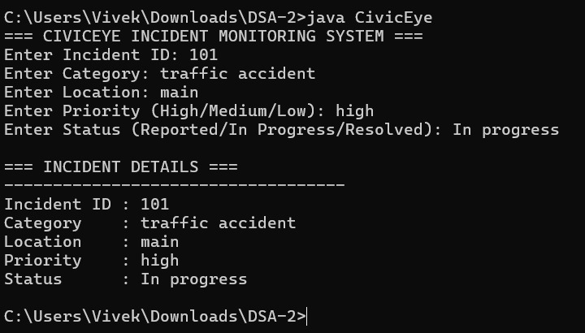

The implemented system efficiently handled incident insertion, searching, and retrieval operations.
Sorted incident reports were generated using tree traversal methods.
The AVL Tree maintained a balanced complaint database, improving performance compared to a normal BST.
.
Time Complexity:

- BST Search/Insert: O(log n) average case
- AVL Insert/Delete/Search: O(log n)
- Tree Traversal: O(n)
Compared to normal BST, the AVL Tree provided better balanced performance for continuous event registrations and scheduling.

Github link: https://github.com/vivekcherukumalli7-beep/DSA2_CIVICEYE_PROJECT

